Table S1. Fixed-effect coefficients (± standard error) of the best-supported Linear Mixed Models for seven soil biological indicators in the MedForECOtron facility. Burn severity reference level: Unburned (UNB). TSF: time since fire (months). Significance: *** p < 0.001; ** p < 0.01; * p < 0.05; ns: not significant; —: predictor not retained in best model. L-TSF: linear TSF; Q-TSF: quadratic TSF; SEV: burn severity; R²_{m}: marginal R²; R²_{c}: conditional R².
Predictor | GLU | UR | PHP | DHA | BSR | GRSP | Cmic
Coeff. (SE)
Intercept | 1.35 (0.10)*** | 1.01 (0.15)*** | 1.72 (0.12)*** | 15.01 (2.37)** | 2.31 (0.20)*** | 1701 (89)*** | 425 (78)***
TSF [linear] | 0.53 (0.35) ns | −1.31 (0.60)* | 0.66 (0.48) ns | −4.60 (0.47)*** | 3.78 (1.27)** | 936 (358)* | —
TSF [quadratic] | 1.27 (0.35)*** | — | 1.33 (0.48)** | — | 5.75 (1.27)*** | 2168 (358)*** | —
LOW severity | −0.22 (0.14) ns | −0.06 (0.21) ns | −0.45 (0.17)* | −3.92 (1.68)* | — | — | —
HIGH severity | −0.46 (0.14)* | −0.46 (0.21)* | −0.73 (0.17)*** | −7.25 (1.68)*** | — | — | —
σ² (residual) | 0.17 | 0.38 | 0.24 | 24.30 | 1.72 | 79540 | —
R²m | 0.34 | 0.18 | 0.36 | 0.70 | 0.42 | 0.51 | —
R²c | 0.34 | 0.18 | 0.36 | 0.70 | 0.42 | 0.51 | —
Best model | Q-TSF+SEV | L-TSF+SEV | Q-TSF+SEV | L-TSF+SEV | Q-TSF | Q-TSF | Null
GLU: β-glucosidase (µmol PNP g⁻¹ h⁻¹); UR: urease (µmol NH₄+ g⁻¹ h⁻¹); PHP: phosphatase (µmol PNP g⁻¹ h⁻¹); DHA: dehydrogenase (mg INTF g⁻¹); BSR: basal soil respiration (mg C kg⁻¹ h⁻¹); GRSP: glomalin-related soil protein (µg protein g⁻¹); C_{mic}: microbial biomass carbon (mg C kg⁻¹).

Table S1. Temporal dynamics of physic-chemical soil properties across experimental fire severity treatments. Values represent the mean ± standard deviation (n = 2 lysimeters per treatment cell).
Treatment | Time | pH | EC  (dS m⁻¹) | OM (%) | N  (%) | C:N | P  (mg kg⁻¹) | K  (cmol_c kg⁻¹) | Ca  (cmol_c kg⁻¹) | Mg  (cmol_c kg⁻¹) | CEC  (cmol_c kg⁻¹) | C (%)
UNBURNED | Pre-fire | 8.28 ± 0.22 | 1.32 ± 0.91 | 4.28 ± 0.85 | 0.17 ± 0.00 | 14.96 ± 3.03 | 6.30 ± 0.64 | 0.62 ± 0.25 | 35.2 ± 0.40 | 6.94 ± 0.16 | 9.74 ± 0.34 | 2.48 ± 0.49
UNBURNED | Post-fire | 8.11 ± 0.02 | 1.39 ± 0.83 | 4.17 ± 0.23 | 0.16 ± 0.00 | 15.26 ± 3.46 | 6.03 ± 0.11 | 0.63 ± 0.20 | 35.3 ± 0.41 | 6.99 ± 0.16 | 10.30 ± 0.42 | 2.48 ± 0.49
UNBURNED | 1 year after | 8.40 ± 0.00 | 1.96 ± 0.30 | 7.37 ± 0.13 | 0.21 ± 0.02 | 21.00 ± 2.12 | 8.00 ± 0.42 | 0.80 ± 0.40 | 39.5 ± 0.25 | 6.45 ± 0.15 | 13.71 ± 0.25 | 4.28 ± 0.01
LOW  BURN  SEVERITY | Pre-fire | 8.42 ± 0.20 | 0.74 ± 0.31 | 3.59 ± 0.24 | 0.15 ± 0.02 | 13.98 ± 1.36 | 5.03 ± 0.15 | 0.54 ± 0.11 | 32.1 ± 0.65 | 5.42 ± 0.84 | 10.82 ± 0.22 | 2.08 ± 0.14
LOW  BURN  SEVERITY | Post-fire | 8.57 ± 0.21 | 0.80 ± 0.31 | 4.87 ± 1.43 | 0.18 ± 0.08 | 18.41 ± 1.32 | 9.58 ± 0.54 | 0.71 ± 0.08 | 36.6 ± 0.35 | 7.01 ± 0.73 | 14.31 ± 0.07 | 3.41 ± 0.16
LOW  BURN  SEVERITY | 1 year after | 8.35 ± 0.07 | 2.97 ± 0.55 | 4.68 ± 0.40 | 0.16 ± 0.00 | 16.55 ± 1.34 | 10.00 ± 0.14 | 0.66 ± 0.04 | 39.1 ± 0.19 | 5.89 ± 0.30 | 13.23 ± 0.25 | 2.65 ± 0.21
HIGH  BURN  SEVERITY | Pre-fire | 8.35 ± 0.03 | 0.59 ± 0.09 | 5.76 ± 1.04 | 0.18 ± 0.03 | 18.68 ± 2.75 | 5.78 ± 0.20 | 0.58 ± 0.02 | 34.5 ± 0.13 | 6.49 ± 0.02 | 7.52 ± 0.68 | 3.34 ± 0.60
HIGH  BURN  SEVERITY | Post-fire | 8.69 ± 0.31 | 0.64 ± 0.00 | 5.58 ± 1.37 | 0.18 ± 0.01 | 17.83 ± 3.08 | 11.43 ± 0.61 | 0.90 ± 0.24 | 36.0 ± 0.20 | 7.22 ± 0.04 | 14.29 ± 0.26 | 3.24 ± 0.79
HIGH  BURN  SEVERITY | 1 year after | 8.20 ± 0.00 | 4.52 ± 0.21 | 6.85 ± 1.24 | 0.25 ± 0.01 | 15.90 ± 2.40 | 18.00 ± 0.42 | 0.75 ± 0.11 | 45.5 ± 0.23 | 9.23 ± 0.53 | 15.57 ± 0.19 | 3.90 ± 0.70
Sampling data: Pre-fire (07 July 2016), Post-fire (14 July 2016), One year after (09 February 2017). Soil variables: pH (1:5 H₂O); EC: electrical conductivity; OM: organic matter; N: total nitrogen; C:N ratio; P: available phosphorus; K: exchangeable potassium; Ca: exchangeable calcium; Mg: exchangeable magnesium; CEC: cation exchange capacity; C: total organic carbon. n = 2 per cell, SD values reflect the range between the two replicates rather than true population variance; interpret accordingly. Some variables show SD = 0, indicating identical values between replicates at that sampling occasion
Table S3. Descriptive statistics (mean ± SE) for seven soil biological indicators in three burn severity treatments across selected sampling time points. POST: immediately after fire; 6, 9, 15 MA: months after fire. GLU: β-glucosidase; UR: urease; PHP: phosphatase; DHA: dehydrogenase; BSR: basal soil respiration; GRSP: glomalin-related soil protein; C_{mic}: microbial biomass carbon.
Treatment | Time | GLU | UR | PHP | DHA | BSR | GRSP | Cmic
 |  | µmol PNP g⁻¹ h⁻¹ | µmol NH₄⁺ g⁻¹ h⁻¹ | µmol PNP g⁻¹ h⁻¹ | mg INTF g⁻¹ | mg C kg⁻¹ h⁻¹ | µg prot g⁻¹ | mg C kg⁻¹
UNB | Pre-fire | 1.19 ± 0.21 | 1.00 ± 0.25 | 1.34 ± 0.19 | 27.11 ± 13.45 | 1.87 ± 0.30 | 1381 ± 159 | 424 ± 370
UNB | POST | 1.19 ± 0.21 | 1.00 ± 0.25 | 1.34 ± 0.19 | 27.11 ± 13.45 | 1.87 ± 0.30 | 1381 ± 159 | 424 ± 370
UNB | 6 MA | 1.03 ± 0.21 | 1.42 ± 0.01 | 1.88 ± 0.20 | 15.03 ± 0.03 | 1.73 ± 0.48 | 822 ± 137 | 243 ± 224
UNB | 9 MA | 1.20 ± 0.16 | 0.85 ± 0.00 | 1.34 ± 0.09 | 13.14 ± 0.63 | 1.43 ± 0.14 | 1296 ± 685 | 483 ± 828
UNB | 15 MA | 1.73 ± 0.15 | 0.91 ± 0.37 | 2.29 ± 0.17 | 0.52 ± 0.33 | 4.23 ± 3.38 | 2040 ± 519 | 904 ± 767
LOW | Pre-fire | 1.27 ± 0.15 | 0.80 ± 0.13 | 1.13 ± 0.12 | 27.33 ± 8.74 | 1.65 ± 0.23 | 1228 ± 86 | 319 ± 30
LOW | POST | 1.25 ± 0.21 | 1.44 ± 0.55 | 1.62 ± 0.29 | 18.59 ± 10.68 | 2.69 ± 0.67 | 1915 ± 148 | 642 ± 289
LOW | 6 MA | 0.77 ± 0.04 | 0.89 ± 0.05 | 0.81 ± 0.18 | 11.29 ± 0.35 | 0.99 ± 0.18 | 841 ± 157 | 478 ± 19
LOW | 9 MA | 0.86 ± 0.10 | 0.48 ± 0.06 | 0.80 ± 0.20 | 11.62 ± 0.12 | 1.49 ± 0.02 | 1352 ± 750 | 414 ± 778
LOW | 15 MA | 1.28 ± 0.11 | 0.47 ± 0.11 | 1.25 ± 0.12 | 0.49 ± 0.11 | 5.38 ± 0.23 | 2079 ± 243 | 275 ± 119
HIGH | Pre-fire | 1.29 ± 0.12 | 0.63 ± 0.09 | 1.36 ± 0.25 | 23.72 ± 23.91 | 1.10 ± 0.12 | 1488 ± 151 | 325 ± 84
HIGH | POST | 1.00 ± 0.17 | 0.72 ± 0.13 | 1.01 ± 0.24 | 11.71 ± 2.98 | 1.77 ± 0.29 | 1935 ± 168 | 511 ± 148
HIGH | 6 MA | 0.24 ± 0.09 | 0.52 ± 0.04 | 0.72 ± 0.10 | 8.77 ± 0.66 | 0.99 ± 0.09 | 1075 ± 177 | 112 ± 76
HIGH | 9 MA | 0.59 ± 0.00 | 0.41 ± 0.02 | 0.50 ± 0.04 | 11.14 ± 0.05 | 0.99 ± 0.11 | 1338 ± 459 | 308 ± 335
HIGH | 15 MA | 1.05 ± 0.14 | 0.38 ± 0.16 | 1.37 ± 0.08 | 0.34 ± 0.08 | 4.45 ± 0.52 | 2167 ± 104 | 216 ± 54
.

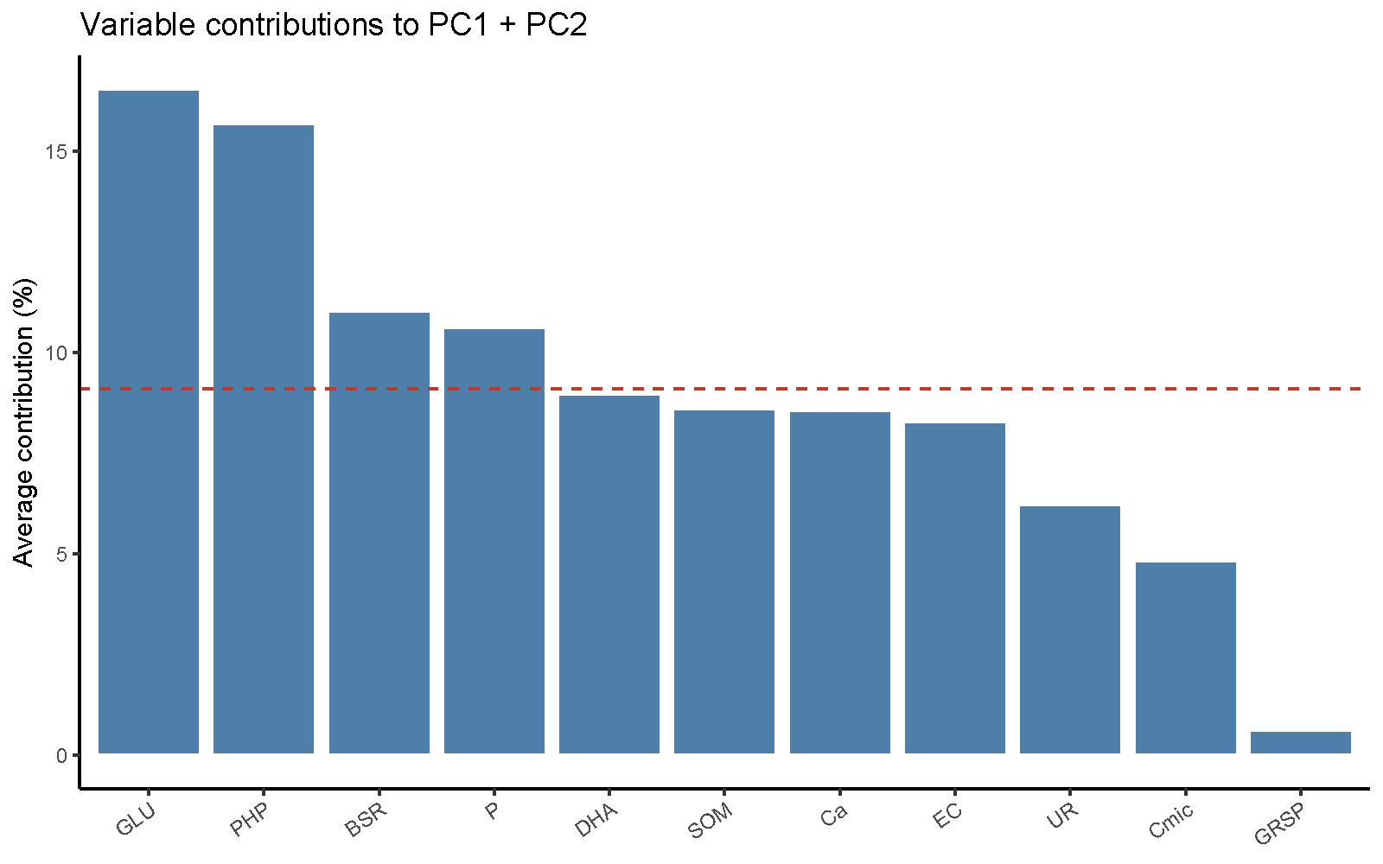Fig. S1. Average contribution (%) of each variable to the first two principal components (PC1 + PC2) of the PCA. The dashed red line indicates the expected uniform contribution (100/11 ≈ 9.1%), serving as a threshold above which variables contribute disproportionately to the multivariate structure. Variables contributing above this threshold: GLU (16.6%), PHP (15.6%), BSR (11.0%), and P (10.6%).

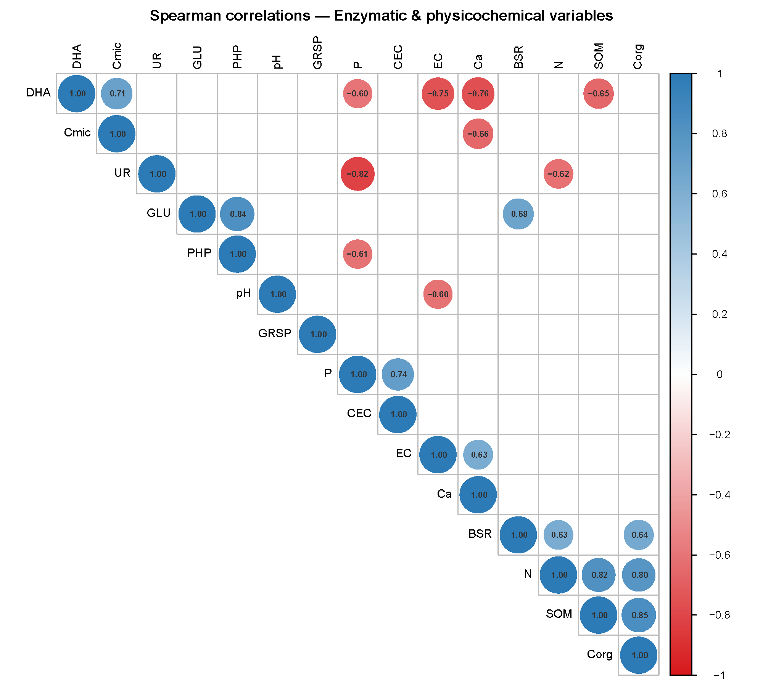Fig. S2. Spearman rank correlation matrix for 11 soil biological and physicochemical variables across all post-fire observations (n = 60 observations). Colour intensity and circle size indicate the strength of correlation (blue: positive; red: negative). Only correlations significant at p < 0.05 are shown (blank cells: non-significant). Variables were ordered by hierarchical clustering. GLU: β-glucosidase; UR: urease; PHP: phosphatase; DHA: dehydrogenase; BSR: basal soil respiration; GRSP: glomalin-related soil protein; Cmic: microbial biomass carbon; SOM: soil organic matter; P: available phosphorus; EC: electrical conductivity; Ca: calcium; N: total nitrogen; Corg: organic carbon; CEC: cation exchange capacity.

Script 1. Full script for the complete linear mixed models (LMMs)
> # ── Full saturated model (quadratic × treatment) ──────────────────────────
> m_full <- tryCatch(
+ lmer(reformulate(c("poly1 * BurnSev", "poly2 * BurnSev", "(1|Monolith)"),
+ response = v),
+ data = dat, REML = FALSE,
+ control = lmerControl(optimizer = "bobyqa")),
+ error = function(e) { cat(" Full model failed:", e$message, "\n"); NULL }
+ )
# ── Candidate models for AICc-based selection ─────────────────────────────
> m1 <- lmer(reformulate(c("poly1 + BurnSev", "(1|Monolith)"), response = v),
+ data = dat, REML = FALSE,
+ control = lmerControl(optimizer = "bobyqa"))
m2 <- lmer(reformulate(c("poly1 + poly2 + BurnSev", "(1|Monolith)"), response = v),
+ data = dat, REML = FALSE,
+ control = lmerControl(optimizer = "bobyqa"))
> m3 <- lmer(reformulate(c("poly1", "(1|Monolith)"), response = v),
+ data = dat, REML = FALSE,
+ control = lmerControl(optimizer = "bobyqa"))
m4 <- lmer(reformulate(c("poly1 + poly2", "(1|Monolith)"), response = v),
+ data = dat, REML = FALSE,
+ control = lmerControl(optimizer = "bobyqa"))
m5 <- lmer(reformulate(c("BurnSev", "(1|Monolith)"), response = v),
+ data = dat, REML = FALSE,
+ control = lmerControl(optimizer = "bobyqa"))
m0 <- lmer(reformulate("(1|Monolith)", response = v),
+ data = dat, REML = FALSE,
+ control = lmerControl(optimizer = "bobyqa"))

Script 2. Full script for the ANOVA linear mixed models (LMMs)
print(lmm_anova)
$GLU
Type III Analysis of Variance Table with Satterthwaite's method
Sum Sq Mean Sq NumDF DenDF F value Pr(>F)
poly1 0.28599 0.28599 1 40 2.2794 0.1389592
poly2 1.61143 1.61143 1 40 12.8436 0.0009095 ***
BurnSev 1.38160 0.69080 2 3 5.5059 0.0990692 .
---
Signif. codes: 0 ‘***’ 0.001 ‘**’ 0.01 ‘*’ 0.05 ‘.’ 0.1 ‘ ’ 1

$UR
Type III Analysis of Variance Table with Satterthwaite's method
Sum Sq Mean Sq NumDF DenDF F value Pr(>F)
poly1 1.7178 1.71780 1 44 4.8375 0.03315 *
BurnSev 1.9737 0.98686 2 44 2.7791 0.07302 .
---
Signif. codes: 0 ‘***’ 0.001 ‘**’ 0.01 ‘*’ 0.05 ‘.’ 0.1 ‘ ’ 1

$PHP
Type III Analysis of Variance Table with Satterthwaite's method
Sum Sq Mean Sq NumDF DenDF F value Pr(>F)
poly1 0.4367 0.43671 1 43 1.9195 0.1730592
poly2 1.7776 1.77757 1 43 7.8129 0.0077211 **
BurnSev 4.2918 2.14589 2 43 9.4318 0.0004015 ***
---
Signif. codes: 0 ‘***’ 0.001 ‘**’ 0.01 ‘*’ 0.05 ‘.’ 0.1 ‘ ’ 1

$DHA
Type III Analysis of Variance Table with Satterthwaite's method
Sum Sq Mean Sq NumDF DenDF F value Pr(>F)
poly1 2111.48 2111.48 1 44 93.6278 1.826e-12 ***
BurnSev 421.25 210.63 2 44 9.3397 0.0004161 ***
---
Signif. codes: 0 ‘***’ 0.001 ‘**’ 0.01 ‘*’ 0.05 ‘.’ 0.1 ‘ ’ 1

$BSR
Type III Analysis of Variance Table with Satterthwaite's method
Sum Sq Mean Sq NumDF DenDF F value Pr(>F)
poly1 14.299 14.299 1 39 8.838 0.005036 **
poly2 33.084 33.084 1 39 20.449 5.583e-05 ***
---
Signif. codes: 0 ‘***’ 0.001 ‘**’ 0.01 ‘*’ 0.05 ‘.’ 0.1 ‘ ’ 1

$GRSP
Type III Analysis of Variance Table with Satterthwaite's method
Sum Sq Mean Sq NumDF DenDF F value Pr(>F)
poly1 875858 875858 1 40 6.831 0.01257 *
poly2 4701572 4701572 1 40 36.668 3.95e-07 ***
---
Signif. codes: 0 ‘***’ 0.001 ‘**’ 0.01 ‘*’ 0.05 ‘.’ 0.1 ‘ ’ 1

$Cmic
Type III Analysis of Variance Table with Satterthwaite's method
Sum Sq Mean Sq NumDF DenDF F value Pr(>F)

Script 3. Full script for the Akaike Information Criterion (AIC) predictive model
> calc_AICc <- function(model) {
+ k <- length(fixef(model)) + 1
+ n <- nobs(model)
+ AIC(model) + (2 * k * (k + 1)) / (n - k - 1)
+ }
> ctrl_ml <- lmerControl(optimizer = "bobyqa",
+ check.conv.singular = .makeCC("ignore", tol = 1e-4))
> ctrl_reml <- lmerControl(optimizer = "bobyqa",
+ check.conv.singular = .makeCC("ignore", tol = 1e-4))
> lmm_results <- list()
> lmm_summaries <- list()
> lmm_anova <- list()
> lmm_posthoc <- list()
> for (v in enzyme_vars) {
+
+ cat("\n══════════════════════════\n")
+ cat("Variable:", v, "\n")
+ cat("══════════════════════════\n")
+
+ dat <- df_post %>%
+ filter(!is.na(.data[[v]])) %>%
+ mutate(
+ poly1 = poly(TSF_months, 2)[, 1],
+ poly2 = poly(TSF_months, 2)[, 2]
+ )
+
+ f1 <- as.formula(paste(v, "~ poly1 + BurnSev + (1|Monolith)"))
+ f2 <- as.formula(paste(v, "~ poly1 + poly2 + BurnSev + (1|Monolith)"))
+ f3 <- as.formula(paste(v, "~ poly1 + (1|Monolith)"))
+ f4 <- as.formula(paste(v, "~ poly1 + poly2 + (1|Monolith)"))
+ f5 <- as.formula(paste(v, "~ BurnSev + (1|Monolith)"))
+ f0 <- as.formula(paste(v, "~ 1 + (1|Monolith)"))
+
+ formulas <- list(
+ "Linear_TSF + BurnSev" = f1,
+ "Quadratic_TSF + BurnSev" = f2,
+ "Linear_TSF only" = f3,
+ "Quadratic_TSF only" = f4,
+ "BurnSev only" = f5,
+ "Null (random only)" = f0
+ )
+
+ models_ml <- lapply(formulas, function(f) {
+ tryCatch(
+ lmer(f, data = dat, REML = FALSE, control = ctrl_ml),
+ error = function(e) NULL
+ )
+ })
+ models_ml <- Filter(Negate(is.null), models_ml)
+
+ aic_table <- data.frame(
+ Model = names(models_ml),
+ AIC = sapply(models_ml, AIC),
+ AICc = sapply(models_ml, calc_AICc)
+ ) %>%
+ mutate(DAICc = AICc - min(AICc)) %>%
+ arrange(AICc)
+
+ cat(" Model selection (AICc):\n"); print(aic_table)
+
+ best_name <- aic_table$Model[1]
+ best_formula <- formulas[[best_name]]
+
+ best_model_reml <- tryCatch(
+ lmer(best_formula, data = dat, REML = TRUE, control = ctrl_reml),
+ error = function(e) { cat(" REML refit failed:", e$message, "\n"); NULL }
+ )
+
+ if (is.null(best_model_reml)) {
+ cat(" Skipping", v, "— model could not be fitted.\n")
+ next
+ }
+
+ lmm_results[[v]] <- best_model_reml
+ lmm_summaries[[v]] <- summary(best_model_reml)
+ lmm_anova[[v]] <- anova(best_model_reml, type = "III")
+
+ cat("\n Best model:", best_name, "\n")
+ cat("\n ANOVA (type III, Satterthwaite):\n")
+ print(lmm_anova[[v]])
+
+ r2_vals <- performance::r2(best_model_reml)
+ cat(sprintf(" Marginal R² = %.3f | Conditional R² = %.3f\n",
+ r2_vals$R2_marginal, r2_vals$R2_conditional))
+
+ if (grepl("BurnSev", best_name)) {
+ emm <- emmeans(best_model_reml, ~ BurnSev)
+ ph <- pairs(emm, adjust = "tukey")
+ lmm_posthoc[[v]] <- ph
+ cat("\n Post-hoc (Tukey):\n"); print(ph)
+ }
+
+ } # ← único cierre del bucle for

══════════════════════════
Variable: GLU
══════════════════════════
Model selection (AICc):
Model AIC AICc DAICc
Quadratic_TSF + BurnSev Quadratic_TSF + BurnSev 46.01566 48.06444 0.000000
Quadratic_TSF only Quadratic_TSF only 50.78811 51.71835 3.653907
BurnSev only BurnSev only 56.29670 57.22693 9.162494
Linear_TSF + BurnSev Linear_TSF + BurnSev 56.39779 57.82636 9.761926
Null (random only) Null (random only) 60.25705 60.52372 12.459281
Linear_TSF only Linear_TSF only 60.48335 61.02880 12.964365

Best model: Quadratic_TSF + BurnSev

ANOVA (type III, Satterthwaite):
Type III Analysis of Variance Table with Satterthwaite's method
Sum Sq Mean Sq NumDF DenDF F value Pr(>F)
poly1 0.28599 0.28599 1 40 2.2794 0.1389592
poly2 1.61143 1.61143 1 40 12.8436 0.0009095 ***
BurnSev 1.38160 0.69080 2 3 5.5059 0.0990692 .
---
Signif. codes: 0 ‘***’ 0.001 ‘**’ 0.01 ‘*’ 0.05 ‘.’ 0.1 ‘ ’ 1
Marginal R² = 0.371 | Conditional R² = 0.388

Post-hoc (Tukey):
contrast estimate SE df t.ratio p.value
UNB - LOW 0.221 0.138 3 1.600 0.3711
UNB - HIGH 0.458 0.138 3 3.318 0.0890
LOW - HIGH 0.237 0.138 3 1.718 0.3335

Degrees-of-freedom method: kenward-roger
P value adjustment: tukey method for comparing a family of 3 estimates

══════════════════════════
Variable: UR
══════════════════════════
Model selection (AICc):
Model AIC AICc DAICc
Linear_TSF + BurnSev Linear_TSF + BurnSev 94.34413 95.77270 0.0000000
Linear_TSF only Linear_TSF only 95.64872 96.19417 0.4214689
BurnSev only BurnSev only 97.35099 98.28122 2.5085206
Quadratic_TSF + BurnSev Quadratic_TSF + BurnSev 96.32998 98.37877 2.6060628
Quadratic_TSF only Quadratic_TSF only 97.63544 98.56567 2.7929725
Null (random only) Null (random only) 98.32990 98.59656 2.8238593

Best model: Linear_TSF + BurnSev

ANOVA (type III, Satterthwaite):
Type III Analysis of Variance Table with Satterthwaite's method
Sum Sq Mean Sq NumDF DenDF F value Pr(>F)
poly1 1.7178 1.71780 1 44 4.8375 0.03315 *
BurnSev 1.9737 0.98686 2 44 2.7791 0.07302 .
---
Signif. codes: 0 ‘***’ 0.001 ‘**’ 0.01 ‘*’ 0.05 ‘.’ 0.1 ‘ ’ 1
Marginal R² = 0.181 | Conditional R² = NA

Post-hoc (Tukey):
contrast estimate SE df t.ratio p.value
UNB - LOW 0.0595 0.211 3 0.282 0.9576
UNB - HIGH 0.4568 0.211 3 2.168 0.2232
LOW - HIGH 0.3973 0.211 3 1.886 0.2866

Degrees-of-freedom method: kenward-roger
P value adjustment: tukey method for comparing a family of 3 estimates

══════════════════════════
Variable: PHP
══════════════════════════
Model selection (AICc):
Model AIC AICc DAICc
Quadratic_TSF + BurnSev Quadratic_TSF + BurnSev 73.87260 75.92138 0.000000
BurnSev only BurnSev only 79.66604 80.59627 4.674889
Linear_TSF + BurnSev Linear_TSF + BurnSev 79.88623 81.31480 5.393418
Quadratic_TSF only Quadratic_TSF only 82.66021 83.59044 7.669058
Null (random only) Null (random only) 87.32580 87.59246 11.671081
Linear_TSF only Linear_TSF only 87.75240 88.29786 12.376473

Best model: Quadratic_TSF + BurnSev

ANOVA (type III, Satterthwaite):
Type III Analysis of Variance Table with Satterthwaite's method
Sum Sq Mean Sq NumDF DenDF F value Pr(>F)
poly1 0.4367 0.43671 1 43 1.9195 0.1730592
poly2 1.7776 1.77757 1 43 7.8129 0.0077211 **
BurnSev 4.2918 2.14589 2 43 9.4318 0.0004015 ***
---
Signif. codes: 0 ‘***’ 0.001 ‘**’ 0.01 ‘*’ 0.05 ‘.’ 0.1 ‘ ’ 1
Marginal R² = 0.378 | Conditional R² = NA

Post-hoc (Tukey):
contrast estimate SE df t.ratio p.value
UNB - LOW 0.448 0.169 3 2.658 0.1477
UNB - HIGH 0.726 0.169 3 4.304 0.0463
LOW - HIGH 0.278 0.169 3 1.646 0.3559

Degrees-of-freedom method: kenward-roger
P value adjustment: tukey method for comparing a family of 3 estimates

══════════════════════════
Variable: DHA
══════════════════════════
Model selection (AICc):
Model AIC AICc DAICc
Linear_TSF + BurnSev Linear_TSF + BurnSev 293.6008 295.0293 0.000000
Quadratic_TSF + BurnSev Quadratic_TSF + BurnSev 294.8177 296.8665 1.837121
Linear_TSF only Linear_TSF only 301.2923 301.8377 6.808380
Quadratic_TSF only Quadratic_TSF only 302.5763 303.5066 8.477251
BurnSev only BurnSev only 346.3382 347.2684 52.239097
Null (random only) Null (random only) 348.4382 348.7049 53.675553

Best model: Linear_TSF + BurnSev

ANOVA (type III, Satterthwaite):
Type III Analysis of Variance Table with Satterthwaite's method
Sum Sq Mean Sq NumDF DenDF F value Pr(>F)
poly1 2111.48 2111.48 1 44 93.6278 1.826e-12 ***
BurnSev 421.25 210.63 2 44 9.3397 0.0004161 ***
---
Signif. codes: 0 ‘***’ 0.001 ‘**’ 0.01 ‘*’ 0.05 ‘.’ 0.1 ‘ ’ 1
Marginal R² = 0.705 | Conditional R² = NA

Post-hoc (Tukey):
contrast estimate SE df t.ratio p.value
UNB - LOW 3.92 1.68 3 2.337 0.1930
UNB - HIGH 7.25 1.68 3 4.317 0.0459
LOW - HIGH 3.32 1.68 3 1.980 0.2634

Degrees-of-freedom method: kenward-roger
P value adjustment: tukey method for comparing a family of 3 estimates

══════════════════════════
Variable: BSR
══════════════════════════
Model selection (AICc):
Model AIC AICc DAICc
Quadratic_TSF only Quadratic_TSF only 146.2848 147.3659 0.000000
Quadratic_TSF + BurnSev Quadratic_TSF + BurnSev 148.8316 151.2316 3.865736
Linear_TSF only Linear_TSF only 161.9905 162.6221 15.256216
Null (random only) Null (random only) 165.8117 166.1194 18.753491
Linear_TSF + BurnSev Linear_TSF + BurnSev 165.0429 166.7096 19.343680
BurnSev only BurnSev only 168.9879 170.0690 22.703111

Best model: Quadratic_TSF only

ANOVA (type III, Satterthwaite):
Type III Analysis of Variance Table with Satterthwaite's method
Sum Sq Mean Sq NumDF DenDF F value Pr(>F)
poly1 14.299 14.299 1 39 8.838 0.005036 **
poly2 33.084 33.084 1 39 20.449 5.583e-05 ***
---
Signif. codes: 0 ‘***’ 0.001 ‘**’ 0.01 ‘*’ 0.05 ‘.’ 0.1 ‘ ’ 1
Marginal R² = 0.417 | Conditional R² = NA

══════════════════════════
Variable: GRSP
══════════════════════════
Model selection (AICc):
Model AIC AICc DAICc
Quadratic_TSF only Quadratic_TSF only 714.1917 715.1219 0.0000000
Quadratic_TSF + BurnSev Quadratic_TSF + BurnSev 714.0145 716.0632 0.9413376
Linear_TSF only Linear_TSF only 739.5173 740.0627 24.9408071
Linear_TSF + BurnSev Linear_TSF + BurnSev 739.6955 741.1240 26.0021399
Null (random only) Null (random only) 741.1019 741.3686 26.2466949
BurnSev only BurnSev only 741.4435 742.3737 27.2517866

Best model: Quadratic_TSF only

ANOVA (type III, Satterthwaite):
Type III Analysis of Variance Table with Satterthwaite's method
Sum Sq Mean Sq NumDF DenDF F value Pr(>F)
poly1 875858 875858 1 40 6.831 0.01257 *
poly2 4701572 4701572 1 40 36.668 3.95e-07 ***
---
Signif. codes: 0 ‘***’ 0.001 ‘**’ 0.01 ‘*’ 0.05 ‘.’ 0.1 ‘ ’ 1
Marginal R² = 0.426 | Conditional R² = 0.540

══════════════════════════
Variable: Cmic
══════════════════════════
Model selection (AICc):
Model AIC AICc DAICc
Null (random only) Null (random only) 741.6271 741.8938 0.000000
Linear_TSF only Linear_TSF only 743.1931 743.7385 1.844712
Quadratic_TSF only Quadratic_TSF only 743.9988 744.9290 3.035245
BurnSev only BurnSev only 744.5766 745.5069 3.613067
Linear_TSF + BurnSev Linear_TSF + BurnSev 746.1329 747.5615 5.667681
Quadratic_TSF + BurnSev Quadratic_TSF + BurnSev 746.9116 748.9604 7.066633

Best model: Null (random only)

ANOVA (type III, Satterthwaite):
Type III Analysis of Variance Table with Satterthwaite's method
Sum Sq Mean Sq NumDF DenDF F value Pr(>F)
Marginal R² = 0.000 | Conditional R² = 0.013

Script 4. Full script for the “PAIRED t-TESTS model: PRE-FIRE vs. 15 MONTHS AFTER”
> df_avg <- df %>%
+ filter(TRAT %in% c("PRE","15 MONTHS AFTER")) %>%
+ group_by(Monolith, BurnSev, TRAT) %>%
+ summarise(across(all_of(enzyme_vars), ~mean(.x, na.rm = TRUE)),
+ .groups = "drop") %>%
+ pivot_longer(cols = all_of(enzyme_vars), names_to = "Variable", values_to = "Value")
> paired_results <- list()
> for (sev in c("UNB","LOW","HIGH")) {
+ for (v in enzyme_vars) {
+ dat_pair <- df_avg %>%
+ filter(BurnSev == sev, Variable == v) %>%
+ pivot_wider(names_from = TRAT, values_from = Value) %>%
+ filter(!is.na(PRE), !is.na(`15 MONTHS AFTER`))
+
+ if (nrow(dat_pair) >= 2) {
+ t_res <- t.test(dat_pair$`15 MONTHS AFTER`, dat_pair$PRE,
+ paired = TRUE, alternative = "two.sided")
+ d_val <- (mean(dat_pair$`15 MONTHS AFTER` - dat_pair$PRE, na.rm = TRUE)) /
+ sd(dat_pair$`15 MONTHS AFTER` - dat_pair$PRE, na.rm = TRUE)
+
+ paired_results[[paste(sev, v, sep = "_")]] <- tibble(
+ BurnSev = sev,
+ Variable = v,
+ t_stat = t_res$statistic,
+ df = t_res$parameter,
+ p_value = t_res$p.value,
+ Cohen_d = d_val,
+ mean_diff = mean(dat_pair$`15 MONTHS AFTER` - dat_pair$PRE, na.rm = TRUE)
+ )
+ }
+ }
+ }
> paired_df <- bind_rows(paired_results) %>%
+ mutate(p_adj = p.adjust(p_value, method = "BH"), # Benjamini-Hochberg
+ sig_label = case_when(
+ p_adj < 0.001 ~ "***",
+ p_adj < 0.01 ~ "**",
+ p_adj < 0.05 ~ "*",
+ TRUE ~ "ns"
+ ))
> print(paired_df)
# A tibble: 21 × 9
BurnSev Variable t_stat df p_value Cohen_d mean_diff p_adj sig_label
<chr> <chr> <dbl> <dbl> <dbl> <dbl> <dbl> <dbl> <chr>
1 UNB GLU 1.15 1 0.456 0.813 0.539 0.683 ns
2 UNB UR -0.312 1 0.807 -0.221 -0.0962 0.892 ns
3 UNB PHP 6.82 1 0.0926 4.83 0.951 0.364 ns
4 UNB DHA -33.0 1 0.0193 -23.3 -21.9 0.364 ns
5 UNB BSR 0.609 1 0.652 0.430 2.36 0.810 ns
6 UNB GRSP 2.11 1 0.282 1.49 659. 0.591 ns
7 UNB Cmic 0.600 1 0.656 0.424 481. 0.810 ns
8 LOW GLU 0.0989 1 0.937 0.0700 0.0116 0.961 ns
9 LOW UR -4.77 1 0.132 -3.37 -0.330 0.364 ns
10 LOW PHP 1.31 1 0.416 0.924 0.127 0.683 ns
# ℹ 11 more rows
# ℹ Use `print(n = ...)` to see more rows

Script 5. Full script for the Principal Component Analysis (PCA) model
> pca_vars <- c("GLU","UR","PHP","DHA","BSR","GRSP","Cmic","SOM","P","EC","Ca")
> df_pca <- df %>%
+ filter(TRAT != "PRE") %>%
+ select(Monolith, BurnSev, TRAT, TSF_months, all_of(pca_vars)) %>%
+ drop_na()
> pca_vars <- c("GLU","UR","PHP","DHA","BSR","GRSP","Cmic","SOM","P","EC","Ca")
> df_pca <- df %>%
+ filter(TRAT != "PRE") %>%
+ select(Monolith, BurnSev, TRAT, TSF_months, all_of(pca_vars)) %>%
+ drop_na()
> # ── Ejecutar PCA con base R ───────────────────────────────────────────────────
> pca_res <- prcomp(df_pca[, pca_vars], center = TRUE, scale. = TRUE)
> # Varianza explicada
> var_exp <- summary(pca_res)$importance[2, ] * 100 # % varianza por PC
> cum_var <- summary(pca_res)$importance[3, ] * 100 # % acumulado
> cat("Variance explained:\n")
Variance explained:
> print(round(var_exp[1:5], 1))
PC1 PC2 PC3 PC4 PC5
37.2 23.3 13.4 9.7 7.3

